BTEC ICT: Level 3 |Task 7 ICT Skills Used | By: Ben Renton
During unit 1 I have used many skills and programs throughout the course, here is what software I have used and why I choose to use them. I have also taken screen shots of my personal statement for example to show that I have used the software for the selected piece of work.
The first main piece of software used throughout the course is Microsoft Word. This was used a lot generally because it’s the best software to use for most written up tasks. I used it for my Personal Statement, Development Plan, PowerPoint evaluation and many other tasks in the other Units (Screenshots Below). I choose Microsoft Word over a program like notepad because it includes a much better verity of fonts etc. Also notepad is very basic even though it is free for any PC with windows installed you are unable to put borders on you documents etc. And it did not include the tools I needed to create professional documents like the Personal Statement. I also chose word because I have used it before quite a lot and I was used to the software. The file type used however is a disadvantage (DOCX) this is because it is not open able by any other program so it has to be converted into another file before its opened. This is the main disadvantage as word cost money and is usually bundled with other programs like ‘Excel’ which the client may not want and is paying for.
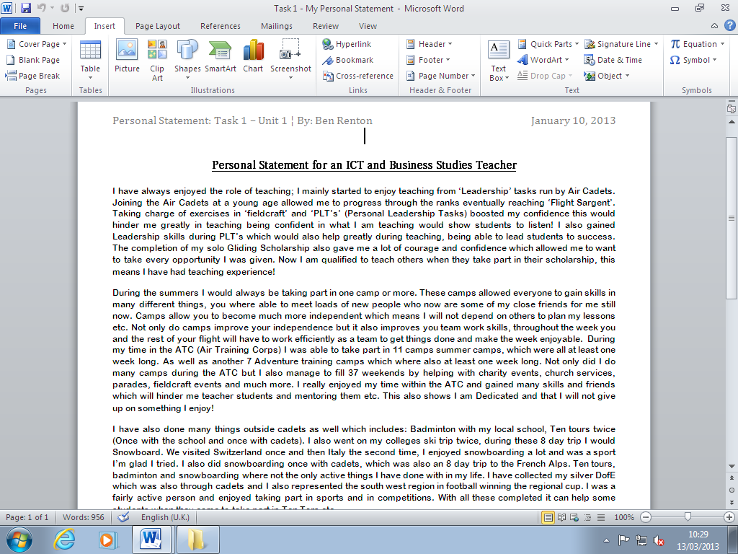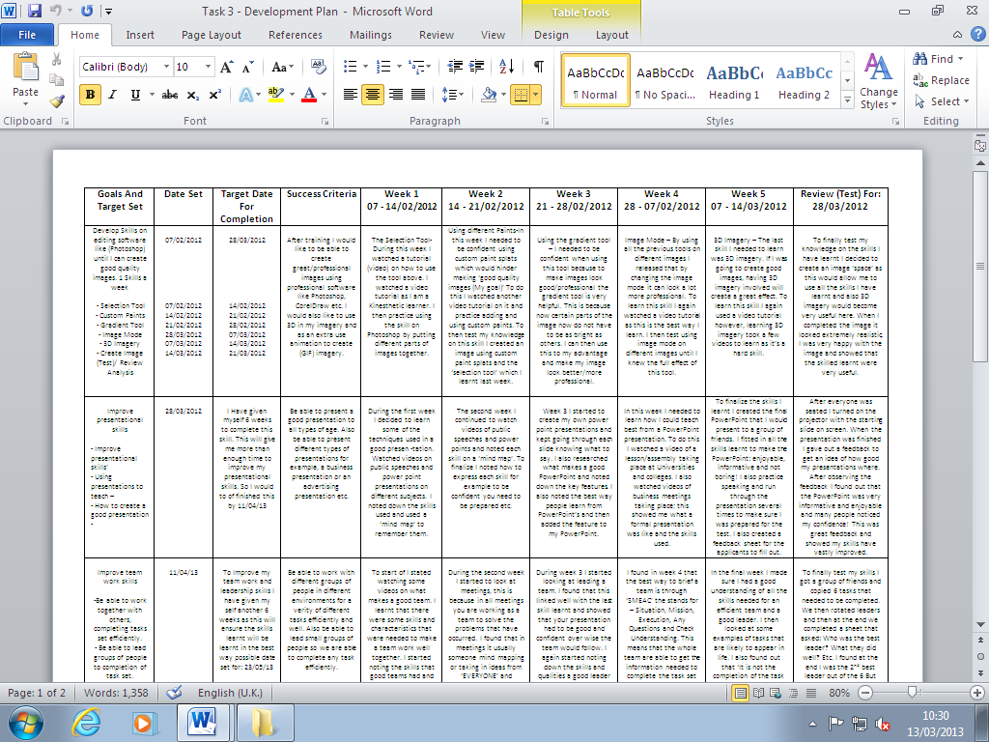
Development Plan
Personal Statement
The next software mostly used throughout unit one is Microsoft PowerPoint. I used this for my Presentation on Barriers of Communication and also many other task in other units. I used PowerPoint because I had already used it in the past and I was very familiar with its tools etc. I used Microsoft PowerPoint purposed to Word because it was more relevant for the situation for example Word you are unable to put animation in and is more for writing than bullet points etc. Again the main disadvantage with PowerPoint was its file type was not open able from other programs which meant you needed installed on to your PC to edit the presentation. However, PowerPoint viewer is free and allows you to open and view presentations but not edit them. This would be good for a finished PowerPoint and then being practiced. I did have already Microsoft Office installed on my home PC which gave me access to most of the Microsoft programs so this problem did not occur to me. Here are some screenshots of my using PowerPoint for my presentation below:
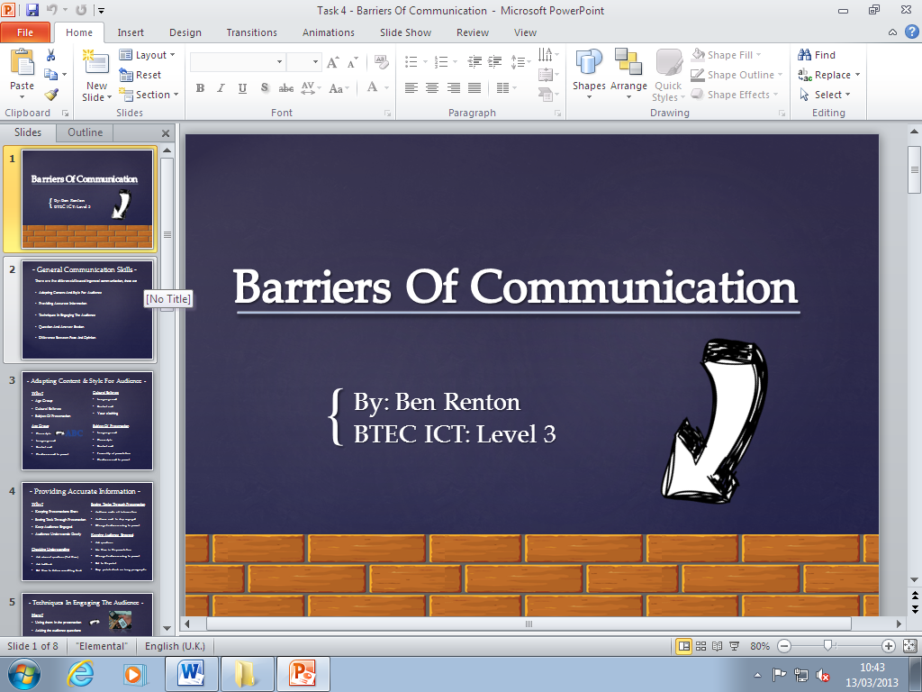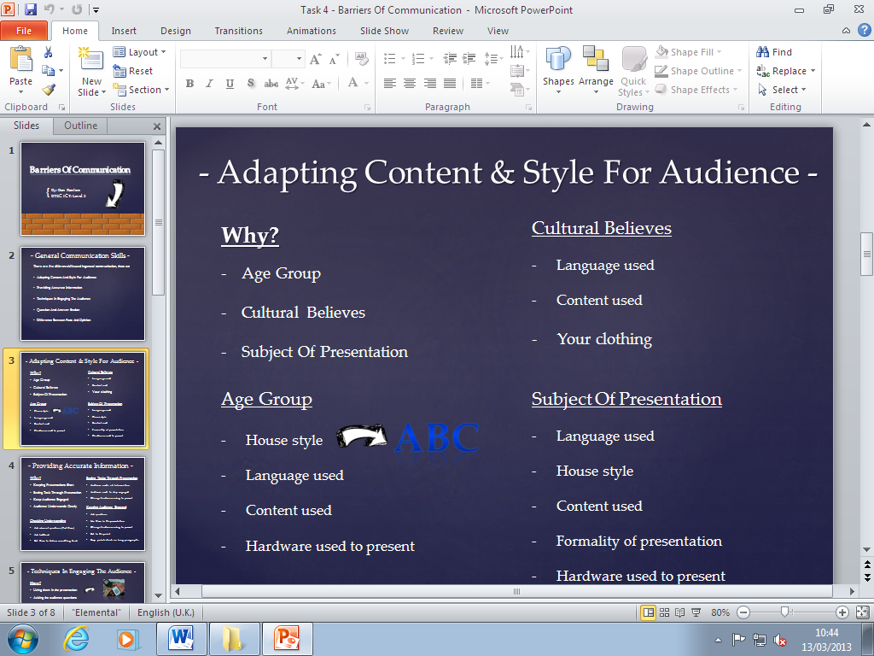
PowerPoint
PowerPoint
The other main used Microsoft Program was Publisher. This was used to create my Leaflet on Professional Development and the glossary on tech terms. I used publisher for these as I was using a lot of imagery in the Professional Development leaflet and I needed to add style to the glossary to prevent it from being boring. Also because this is a Microsoft product it does not open with other programs. So because it costs this is a disadvantage. However this again did not occur to me as I already had the program installed at home so I was able to continue with the task in my own time rather than just at college. I was also familiar with Publisher as I had used it in other units so it was much more efficient using this.
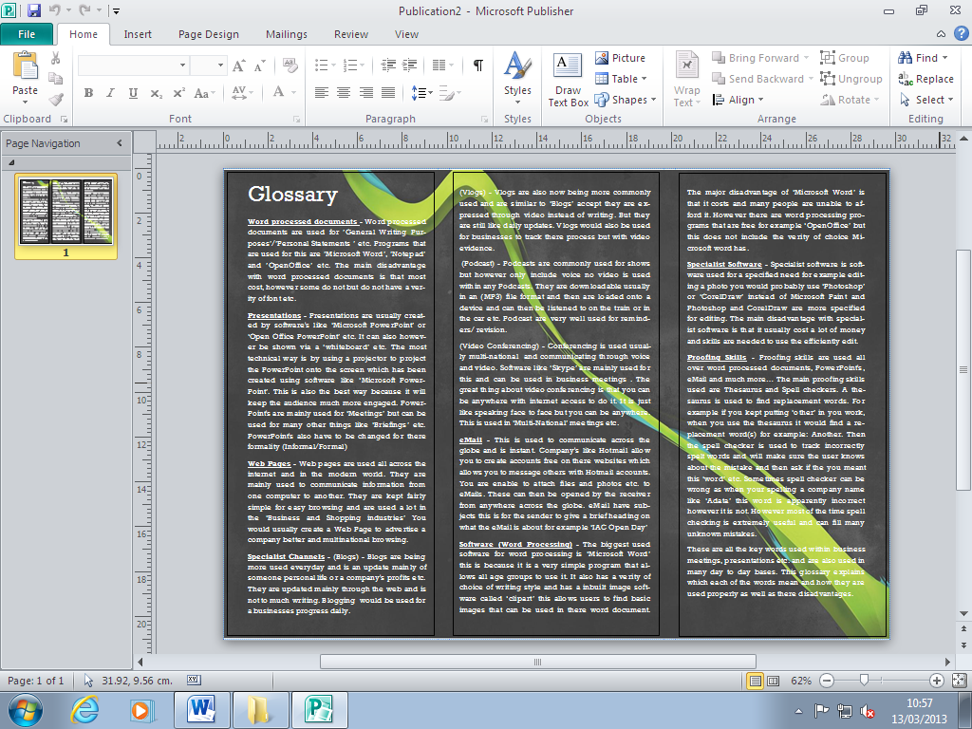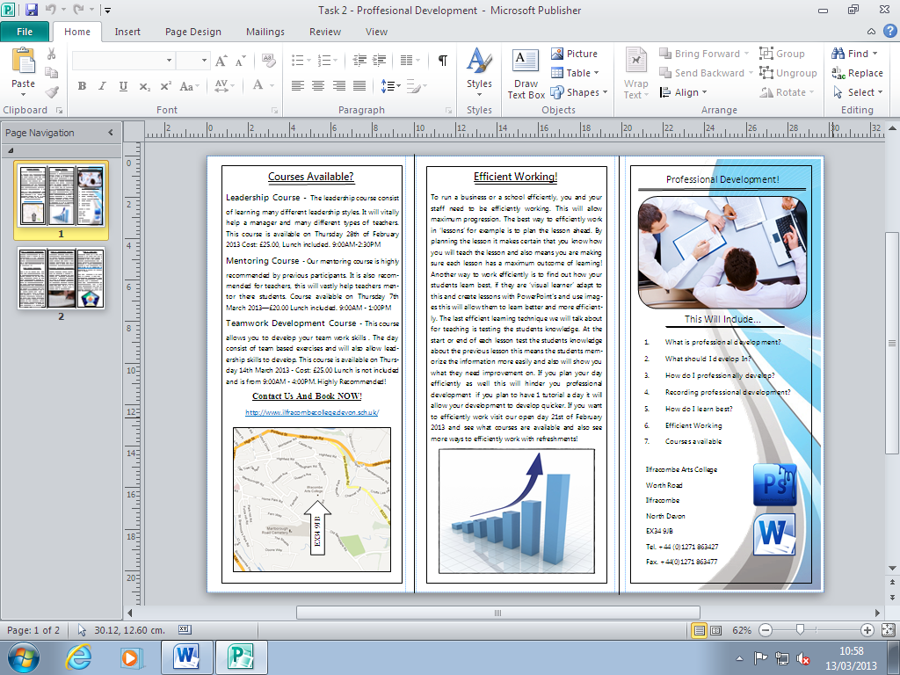
Professional Development
Glossary
The last Microsoft Product I used was Visio; I used Visio manly to create mind maps on the computer. I already had previously used it and was the obvious easy choice as I already had it installed to my home PC. Visio was used for my mind map on Skills. Again because this is a Microsoft product it’s not free. However again I already had it installed so this problem did not occur once again. Visio is a great program for computer min maps etc. Because it’s very simple to use and gives clients the tools to create good quality mind maps. The screen shot below shows my mind map on Visio.
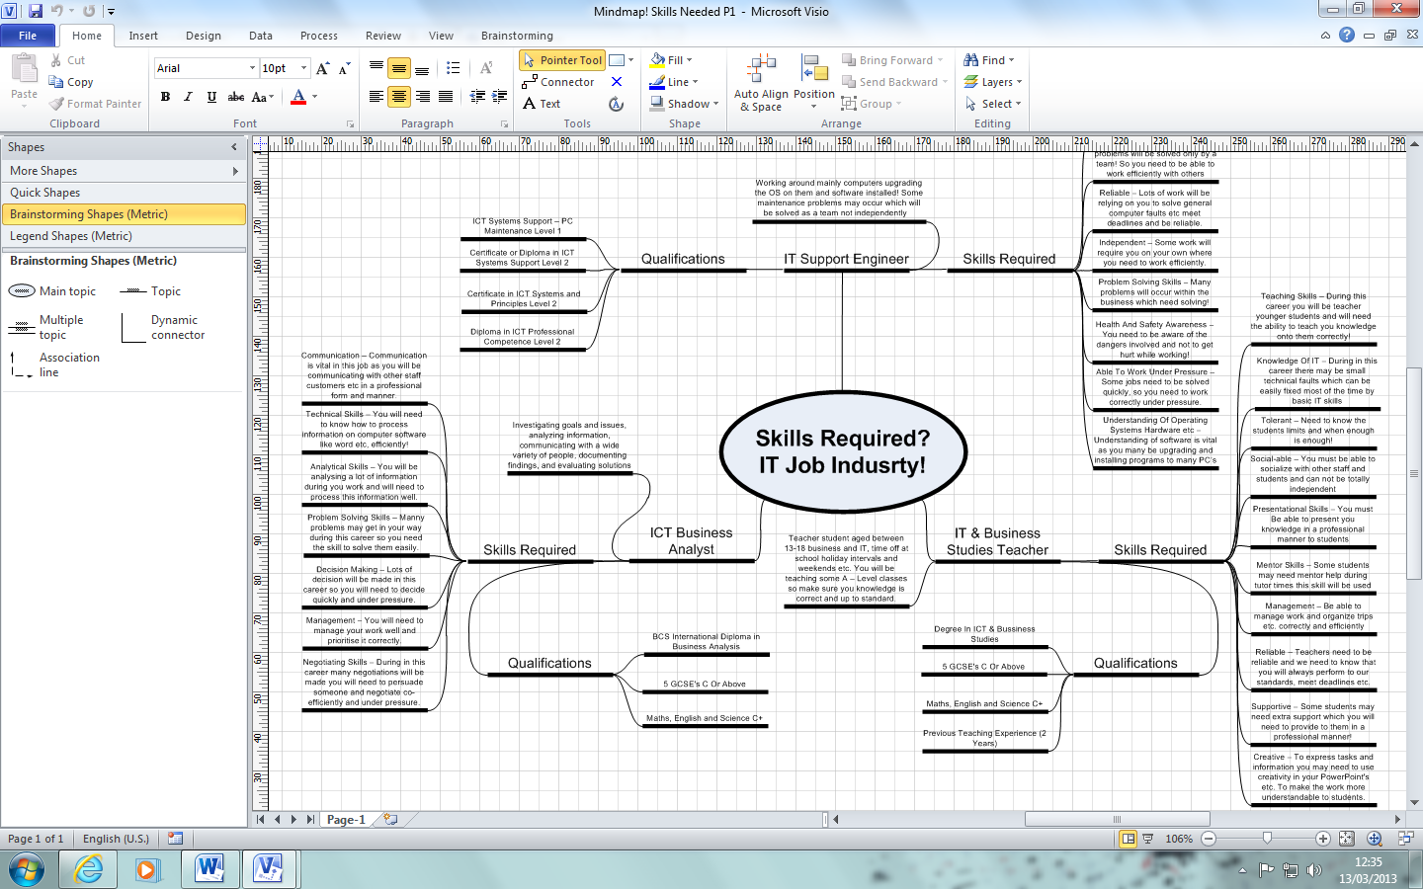
The other software I have used is Photoshop. I didn’t use Photoshop in this unit to complete task, I used it to edit images and text to put onto my work like My Professional Development leaflet. I chose Photoshop because I used this lot in computer graphics unit 30 so I already had previous experience in this. I chose Photoshop also because of the wide verity of tools available and allowed me to edit images however I needed. The main disadvantage with Photoshop is obviously it cost a lot and I did not have this installed at home. This was a disadvantage as I could only continue with this word at college. The screenshots below show what I was doing of Photoshop to edit text etc.
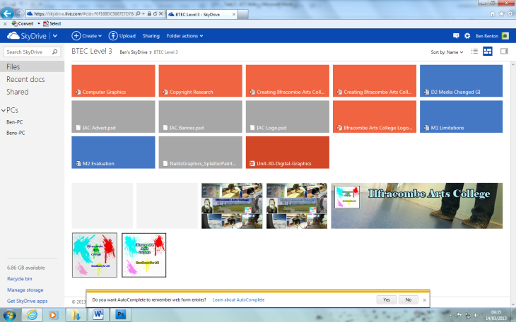
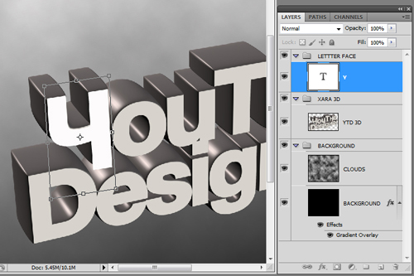
The last software used throughout this unit is SkyDrive. I used SkyDrive as online storage, I chose SkyDrive over a USB stick because if I was to lose my memory stick my work would have been lost. However, I still kept a memory stick as it was quick and much simpler than uploading it to SkyDrive each lesson. Once I completed a task I would upload it to SkyDrive so all completed tasks were backed up. SkyDrive has a major advantage and that it is free and gives any user 2GB of storage free which is easily enough to store all my work. The only disadvantage is it takes time to upload and download documents that are stored. The screenshot above shows SkyDrive being used online.

